Name________________________________________Date______________________
Chapter 2: The Government of South Carolina

True/False
Indicate whether the statement is true or false.

____ 1. All bills to be considered by the South Carolina legislature must first go through the governor.

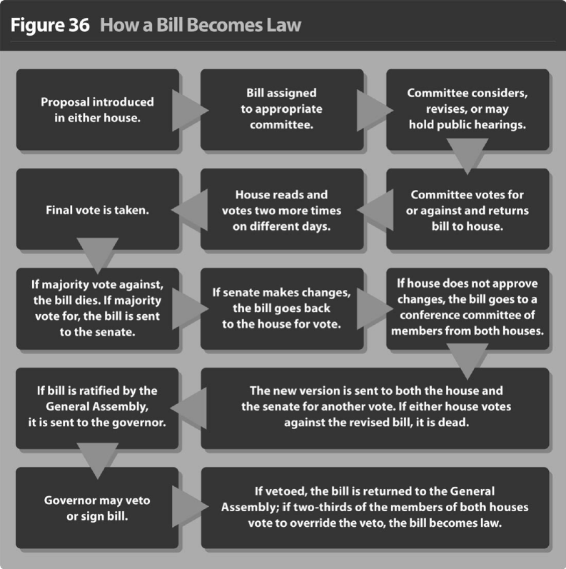

____ 2. According to the chart, if the Senate makes changes to a House bill, it dies.

____ 3. According to the chart, if a committee approves a bill, it is sent to the full house for consideration.

____ 4. South Carolina’s Supreme Court has five justices.

____ 5. The freedoms that you enjoy as a U.S. citizen are absolute.

Multiple Choice
Identify the choice that best completes the statement or answers the question.

____ 1. What service is NOT supplied by a special service district?
a. | fire
b. | library
c. | sewer
d. | water

____ 2. What is the only state-level body that can levy taxes, fees and fines to raise revenue?
a. | executive branch
b. | judicial branch
c. | legislative branch
d. | Supreme Court

____ 3. Which is the lowest level court at the county level?
a. | Family Court
b. | Magistrate Court
c. | Municipal Court
d. | Probate Court

____ 4. Which is NOT a duty of the governor of South Carolina?
a. | to keep order
b. | to carry out the laws
c. | to be a spokesperson for the state
d. | to approve all the bills passed by the legislature

____ 5. Which is an informal power of the Governor of South Carolina?
a. | to submit an executive budget to the legislature
b. | to be able to veto acts of the General Assembly
c. | to fill a number of offices with political supporters
d. | to deal with crises such as natural disasters and riots

____ 6. Which court deals primarily with wills and deeds?
a. | Family Court
b. | Magistrate Court
c. | Municipal Court
d. | Probate Court

____ 7. Which court is primarily a trial court?
a. | Circuit Court
b. | Family Court
c. | Magistrate Court
d. | Probate Court

____ 8. Which is NOT a service of county government?
a. | fire protection
b. | libraries
c. | parks
d. | roads

____ 9. Which of the following is a right of citizenship?
a. | voting
b. | paying taxes
c. | possessing guns
d. | serving on juries

____ 10. Which is a responsibility of citizenship?
a. | going to church
b. | paying taxes
c. | speaking freely
d. | demonstrating peacefully

____ 11. How many consecutive terms can a person serve as South Carolina’s governor?
a. | 2
b. | 3
c. | 4
d. | 5

Completion
Complete each statement.

1. The length of one term in the South Carolina House of Representatives is _____________ years.

2. The presiding officer of South Carolina’s Senate is the ______________________________.

3. The governor heads the _______________________ branch of government.

Matching

Match the term with its definition.
a. | appeal | h. | incorporated
b. | aristocracy | i. | lobbyist
c. | authoritarian | j. | monarchy
d. | bail | k. | oligarchy
e. | democracy | l. | patronage
f. | dictator | m. | probable cause
g. | filibuster | n. | revenue

____ 1. rule by one person, e.g., king, emperor

____ 2. operational funds for the government

____ 3. power to distribute offices, grant favors, or promote an agenda

____ 4. ruled by a small class of people that inherit their authority

____ 5. person who influences legislators to vote for bills that benefit the organizations they represent

____ 6. a rule that allows unlimited debate

Chapter 2: The Government of South Carolina
Answer Section

TRUE/FALSE

1. ANS: F
All bills to be considered by the South Carolina legislature start in either the Senate or House of Representatives.

PTS: 1 DIF: Comprehension REF: Chapter 2 Section 1
TOP: Legislative Branch

2. ANS: F
According to the chart, if the Senate makes changes to a House bill, the bill goes back to the original house for a vote.

PTS: 1 DIF: Application REF: Chapter 2 Section 1
TOP: How a Bill Becomes a Law

3. ANS: T PTS: 1 DIF: Application REF: Chapter 2 Section 1
TOP: How a Bill Becomes a Law

4. ANS: T
The South Carolina Supreme Court has five justices--one of whom is the chief justice.

PTS: 1 DIF: Application REF: Chapter 2 Section 1
TOP: Judicial Branch

5. ANS: F
The freedoms that you enjoy as a U.S. citizen are not absolute.

PTS: 1 DIF: Comprehension REF: Chapter 2 Section 2
TOP: Citizenship

MULTIPLE CHOICE

1. ANS: B PTS: 1 DIF: Comprehension
REF: Chapter 2 Section 2 TOP: Local Government

2. ANS: C PTS: 1 DIF: Application REF: Chapter 2 Section 1
TOP: Legislative Branch

3. ANS: B PTS: 1 DIF: Knowledge REF: Chapter 2 Section 1
TOP: Judicial Branch

4. ANS: D PTS: 1 DIF: Analysis REF: Chapter 2 Section 1
TOP: Executive Branch

5. ANS: C PTS: 1 DIF: Analysis REF: Chapter 2 Section 1
TOP: Executive Branch

6. ANS: D PTS: 1 DIF: Comprehension
REF: Chapter 2 Section 1 TOP: Judicial Branch

7. ANS: A PTS: 1 DIF: Comprehension
REF: Chapter 2 Section 1 TOP: Judicial Branch

8. ANS: A PTS: 1 DIF: Application REF: Chapter 2 Section 2
TOP: Local Government

9. ANS: C PTS: 1 DIF: Application REF: Chapter 2 Section 2
TOP: Citizenship

10. ANS: B PTS: 1 DIF: Analysis REF: Chapter 2 Section 2
TOP: Citizenship

11. ANS: A PTS: 1 DIF: Knowledge REF: Chapter 2 Section 1
TOP: Executive Branch

COMPLETION

1. ANS: 2

PTS: 1 DIF: Knowledge REF: Chapter 2 Section 1
TOP: Legislative Branch

2. ANS: lieutenant governor

PTS: 1 DIF: Knowledge REF: Chapter 2 Section 1
TOP: Legislative Branch

3. ANS: executive

PTS: 1 DIF: Knowledge REF: Chapter 2 Section 1
TOP: Executive Branch

MATCHING

1. ANS: J PTS: 1 DIF: Knowledge REF: Chapter 2 Introduction
TOP: Vocabulary

2. ANS: N PTS: 1 DIF: Knowledge REF: Chapter 2 Section 1
TOP: Vocabulary

3. ANS: L PTS: 1 DIF: Knowledge REF: Chapter 2 Section 1
TOP: Vocabulary

4. ANS: B PTS: 1 DIF: Knowledge REF: Chapter 2 Introduction
TOP: Vocabulary

5. ANS: I PTS: 1 DIF: Knowledge REF: Chapter 2 Section 2
TOP: Vocabulary

6. ANS: G PTS: 1 DIF: Knowledge REF: Chapter 2 Section 1
TOP: Vocabulary

